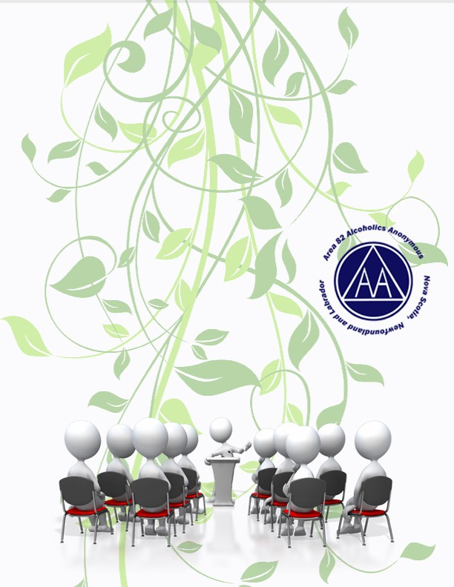
“A.A.’s Three Legacies – Our Common Solution"

Area 82 Virtual Spring Assembly
May 26th to 28th
All are Welcome !!

https://us02web.zoom.us/j/89962135907 Meeting ID: 899 6213 5907
One tap mobile
+14388097799,,89962135907# Canada
+15873281099,,89962135907# Canada

Registration will be $10.00 if you (or your Group) can afford it)
This will cover Assembly costs and allow for our principle of Self Support
Payment can be made by e-transfer to treasurer@area82aa.org

